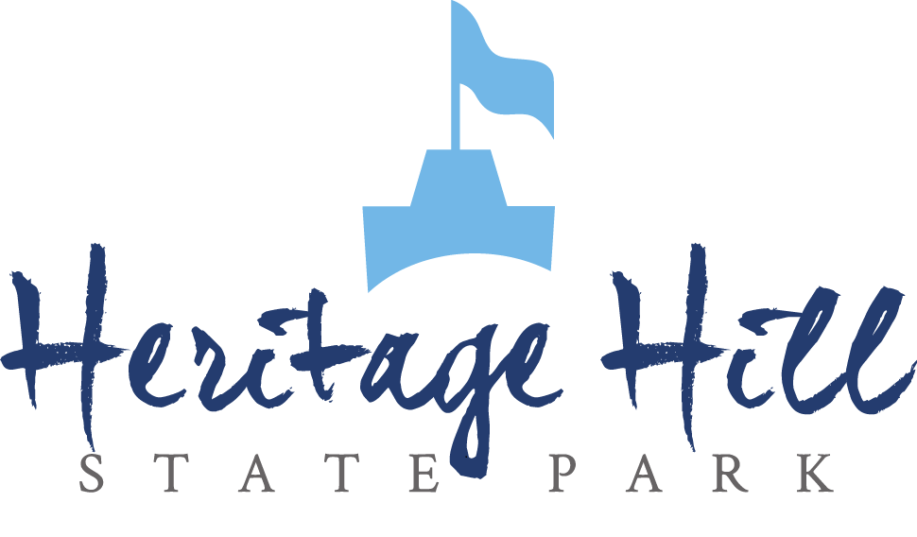

Spring Tours

Classroom Activities Booklet

Table of Contents
Classroom Activities 2
La Baye (1672-1830) 3
Pre-Visit Activity 3
How Far Would You Go? 3
Post-Visit Activity 4
Sell It! 4
Fort Howard (1836) 10
Pre-Visit Activity 10
Healthy Plate 10
Post-Visit Activity 13
Map Skills 13
Growing Community (1850-1912) 16
Pre-Visit Activity 16
Create a Historic Site 16
Post-Visit Activity 19
Who am I? 19
Belgian Farm (1905) 23
Pre-Visit Activity 23
Immigrants’ Trunk 23
Post-Visit Activity 26
Thinking Like a Historian 26
Write It! Define It! Draw It! Use It! 31

Classroom Activities

In this booklet, we have provided you with some activities to help your students gain some background knowledge about the park. Both pre-visit and post-visit activities are included. We have saved it as a Word Document so you can edit it how you please. We recommend printing it one-sided.

The vocabulary that is listed covers some topics that may be covered in the buildings you visit. Vocabulary words used in the activities are highlighted throughout the booklet. Please be aware that not all of the buildings will be open, therefore not all topics will be covered. Some of them will be gated, and others remained closed to protect the building and its artifacts. The vocabulary activity worksheet is the last page of this document (for 3rd grade and up).

We hope you enjoy your visit!

La Baye (1672-1830)

• Vocabulary •
- Trade goods – any item that could be of value to another person; an item that would be traded for something else at the fur trader’s post.

- Rendezvous – a place agreed on for a meeting; a place that the fur traders met to get trade goods.

- Pelt – the skin of an animal with the wool, fur, or hair still on it.

- Barter – to trade one thing for another without the use of money.

- Bourgeois – the person in charge of the trading post.

- “Three sisters” – a style of planting corn, beans, and squash; it is believed that each of the three crops helps the others grow.

How it works: Corn acts as a pole for the bean vines to climb. Beans improve the quality of the soil by fixing nitrogen on their roots. The bean vines stabilize the corn plants making them less likely to blow over in the wind. The squash acts as a living mulch, keeping weeds from growing close to the plants and keeping the moisture in the soil from evaporating. Squash helps keep predators from approaching the corn and beans. At the end of the season, the crop residue can be put back into the soil to improve its quality.

- Court – a building or room where legal cases are heard.

- Trial – the hearing and judgment of a case in court.

- Missionary – a person sent on a religious journey to convert people to their religion, especially one sent to promote Christianity in a foreign country.

- Bark Chapel – a structure built by Native Americans for priests intended for use as a place of worship; typically built on sapling framework and covered with elm bark (the one at Heritage Hill is a replica and is more substantially framed and covered with cedar bark, as it is more readily available today).

- Artifact – any item of cultural or historical interest.

Pre-Visit Activity

How Far Would You Go?
(5th Grade & Up)

Today we have many modes of transportation – cars, boats, airplanes, etc. During the Fur Trade era, modes of transportation were very limited. Historians often refer to rivers as the “highways” of the time. Other than waterways, the fur traders mostly relied on their feet. Because of this, traveling took a long time and was a major part of the lives of the people of this time. The fur traders in what is now the Green Bay area would travel to Michilimackinac for the Rendezvous once a year. This is about 250 miles away if you travel on land and about 180 nautical miles away if you travel on water. Fur traders would carry packs weighing about 90 pounds apiece to the Rendezvous filled with items that they could trade.

This activity is simply a discussion based activity that you can use to get your students to compare the past and present.
Ask your students…

- How long do you think this trip took the fur traders? (Hint: they took a canoe.)
(5-7 days one way)

- Today, how long would it take to Michilimackinac by car and bicycle?
(Car: about 4.5 hours
Bicycle: almost 22 hours)

- Would you rather travel to Michilimackinac today or during the fur trade era? Why?

- What are some places you travel to often?

- Imagine walking or taking a canoe to these places. Would you go to these places as often if you didn’t have a car or a bicycle? Why not?

Post-Visit Activity

Sell It!
(4th Grade & Up)

Your students will learn about different trade goods from the fur trade era. In this activity, students will learn a few more facts about the different trade goods. Divide your students into groups of 3-5 and give each group an information card about each artifact on the following pages. In this activity, the students will make a commercial to try to “sell” their artifact.

First, give the students 5-10 minutes to answer the questions on their worksheets. Instruct them to make a commercial to sell their artifact to the rest of the class – but not until after they’ve answered the questions. All of the questions that are on the worksheet must be answered in the commercial. Every group member must have a role in the commercial.

If you wish, ask your students after each presentation or the activity if they would trade for each item from the fur trader. Why or why not?

The answer key follows the artifact information cards.

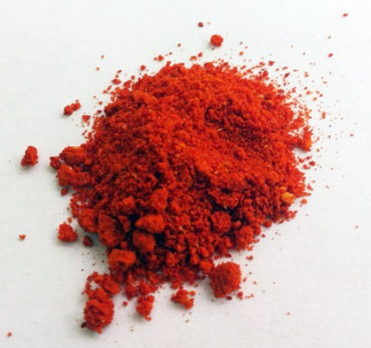
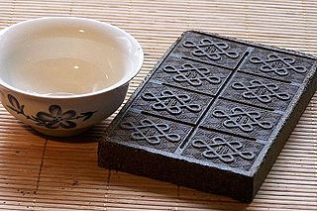
Artifact 2: Vermillion

What is the artifact made of?

What would it have been used for?

Who would have used it?

Where would it have been used?

What does it tell us about the life and times of the people who used it?

Is there a similar item that is used today?
Artifact 1: Tea

What is the artifact made of?

What would it have been used for?

Who would have used it?

Where would it have been used?

What does it tell us about the life and times of the people who used it?

Is there a similar item that is used today?

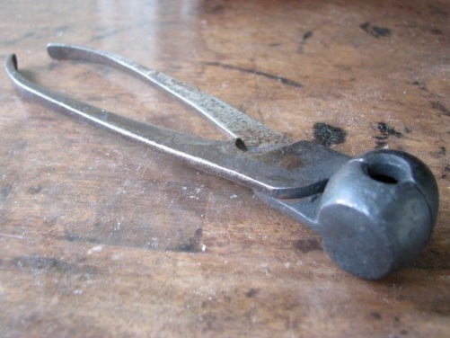
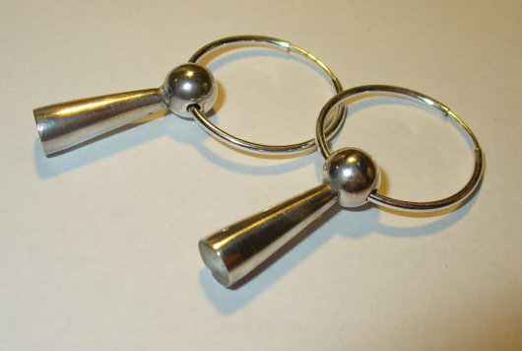
Artifact 4: Musket Ball Mold

What is the artifact made of?

What would it have been used for?

Who would have used it?

Where would it have been used?

What does it tell us about the life and times of the people who used it?

Is there a similar item that is used today?
Artifact 3: Trade Silver

What is the artifact made of?

What would it have been used for?

Who would have used it?

Where would it have been used?

What does it tell us about the life and times of the people who used it?

Is there a similar item that is used today?

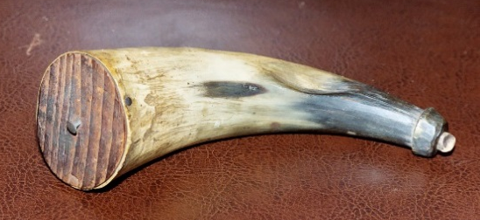
Artifact 5: Powder Horn

What is the artifact made of?

What would it have been used for?

Who would have used it?

Where would it have been used?

What does it tell us about the life and times of the people who used it?

Is there a similar item that is used today?
Answer Key:

Artifact 1: Tea
- What is the artifact made of?
  - Highly concentrated Chinese black tea.

- What would it have been used for?
  - A trade item, used to make tea to drink.

- Who would have used it?
  - Anyone in the fur trade.

- When would it have been used?
  - Whenever someone wanted a hot drink.

- What does it tell us about the life and times of the people who used it?
  - Even in the fur trade era, hot and flavored drinks were valuable.

- Is there a similar item that is used today?
  - Black tea can be found in tea bags or loose leaf, but it is no longer sold in this form.
  - Other hot drinks that people drink to warm up such as hot chocolate, coffee, and other kinds of tea.

Artifact 2: Vermillion
- What is the artifact made of?
  - The powdered mineral cinnabar (made into a red powder)

- What would it have been used for?
  - It would have been mixed with grease and used by the Native Americans to paint their faces and horses for ceremonies, dances, and in war.

- Who would have used it?
  - Native Americans, it became a trade item, and then was available to trappers and anyone in the fur trade.

- When would it have been used?
  - The Native Americans would have used it to pain their faces and horses for ceremonies, dances, and in war.

- What does it tell us about the life and times of the people who used it?
  - Native Americans were very spiritual people. Body modification (face paint) was a spiritual aspect of the Native Americans’ lives. Different shapes and colors painted on their faces represented different things such as a spirit protecting them during war, wisdom, mourning, or others.

- Is there a similar item that is used today?
  - Face paint, make up, any kind of dye.

Artifact 3: Trade Silver
- What is the artifact made of?
  - Silver

- What would it have been used for?
  - Jewelry, decoration for clothing or bags, a valuable trade item.

- Who would have used it?
  - Native Americans used it for jewelry or decoration for clothing or bags, but would trade it with fur traders if they needed to trade for an item.

- When would it have been used?
  - Anytime a Native American wanted to wear jewelry, decorate their belongings, or needed to trade something.

- What does it tell us about the life and times of the people who used it?
  - Body modifications (piercings and jewelry) was a spiritual aspect of Native Americans’ lives. Different piercings could symbolize different things such as wealth or masculinity.

- Is there a similar item that is used today?
  - Jewelry, any kind of decorations for clothing or accessories including key chains, stickers, etc.

Artifact 4: Musket Ball Mold
- What is the artifact made of?
  - Could be made of various metals, this one is made of iron.

- What would it have been used for?
  - To make lead bullets to shoot out of the muskets.

- Who would have used it?
  - Trappers

- When would it have been used?
  - Whenever a trapper needed to make bullets (trappers often retrieved the lead bullets from the animals they shot to reuse them)

- What does it tell us about the life and times of the people who used it?
  - People needed to be skilled. They often would have to make the things they wanted because the fur trader wouldn’t always have them.

- Is there a similar item that is used today?
  - Ammunition, no longer made of lead.
  - Some gun owners still reload their used shell casings.

Artifact 5: Powder Horn
- What is the artifact made of?
  - A cow, ox, or buffalo horn.

- What would it have been used for?
  - To hold gunpowder.

- Who would have used it?
  - A fur trader, voyageur, and later Native Americans.

- When would it have been used?
  - Whenever a musket needed to be loaded.

- What does it tell us about the life and times of the people who used it?
  - They made use of the resources they were given.

- Is there a similar item that is used today?
  - Any kind of container that can protect gunpowder and keep it dry.

Fort Howard (1836)

• Vocabulary •
- Fort – a strong building or group of buildings used for protection and defense.

- Company – a group of soldiers.

- Matron – woman who works in the hospital.

- Attendant – a man who cleans the hospital and the items in it.

- Steward – a man who works in the hospital on record keeping of patients and medical instruments and medicines, overlooks the attendants’ and matrons’ work, and helps the surgeon.

- Mess hall – where patients in the hospital eat.

- Store room – a storage room for supplies in the hospital like medicines, sheets, blankets, bed sacks, etc.

- Dispensary – where the medicine is kept in the hospital; where the medicine is given out.

- Slate – a tablet used for writing on.

- Musket – a muzzle-loading gun that was once used by soldiers.

- Stockade – a line of tall posts that are set in the ground and used as a barrier to protect or defend a place.

Pre-Visit Activity

Healthy Plate
(1st Grade & Up)

Worksheet for this activity is on the following page.

Name: _____________________________________________________ Date: ___________________

Healthy Plate at Fort Howard
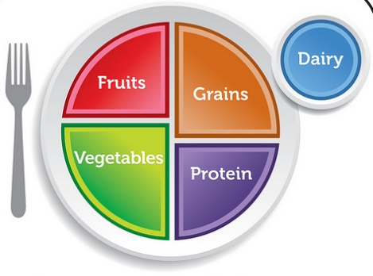
A typical soldier at Fort Howard did not eat very well. His food was bland, boring, and there wasn’t much variety. Here is an example of what an enlisted man’s meals looked like in a day:

Breakfast: bread, boiled beef or pork, cornmeal or oatmeal mush, and coffee.

Lunch: bread, soup or stew, and coffee.

Supper: bread only, supplemented by garden vegetables (if they are available) or fresh meat twice weekly.
Diagram of a Healthy Plate

Look at the healthy plate diagram on this page. List the food groups that are included in each soldier’s meal below.

Breakfast: | Lunch: | Supper:
__________________ | ____________________ | ____________________
__________________ | ____________________ | ____________________
__________________ | ____________________ | ____________________
__________________ | ____________________ | ____________________

Were the soldiers eating healthy, balanced meals? _________________________

Write down what you had for breakfast this morning, what you had (or will have) for lunch today, and later this evening, write down what you have for supper.

Breakfast: | Lunch: | Supper:
______________________ | ____________________ | ____________________
______________________ | ____________________ | ____________________
______________________ | ____________________ | ____________________
______________________ | ____________________ | ____________________

Now list the food groups that your meals fell into.

Breakfast: | Lunch: | Supper:
_____________________ | ____________________ | ____________________
_____________________ | ____________________ | ____________________
_____________________ | ____________________ | ____________________
_____________________ | ____________________ | ____________________

How was your meal similar to a soldier at Fort Howard’s?

____________________________________________________________________________________________________________________________________________________________________________________________________________________________________________________________________________________________________________________

How was it different?

____________________________________________________________________________________________________________________________________________________________________________________________________________________________________________________________________________________________________________________

Post-Visit Activity

Map Skills
(5th Grade & Up)

Use the maps provided for this activity. The map is an example of the Wisconsin Territory and how it changed. For question 1, have the students outline the area that it covered starting in 1836 (the larger area).

Worksheet for this activity is on the following page.

Name: _________________________________________________ Date: _______________________

Map Skills
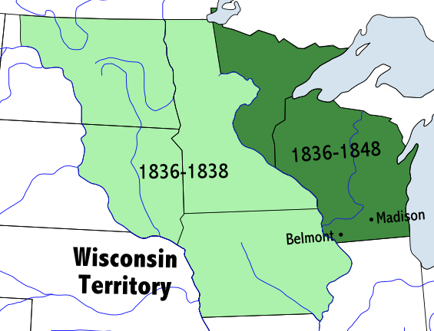

Draw on the maps and to answer the questions.
- Wisconsin became a territory in 1836. This is the year that you learned about at Fort Howard. Draw the border of the Wisconsin Territory in red on the map below.
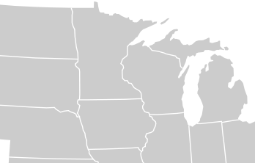
- Around what geographical feature were Fort Howard and Camp Smith located? Draw this geographical feature in blue on the map of Northeast Wisconsin counties on the following page. Why were they located there? ________________________________________________________________________________________________________________________________________________________________________

- On the map of Northeast Wisconsin counties, put a green star where you go to school and an orange star where Heritage Hill is. How far is it between these two cities? (Use Google Maps to find the answer!) _________________________________
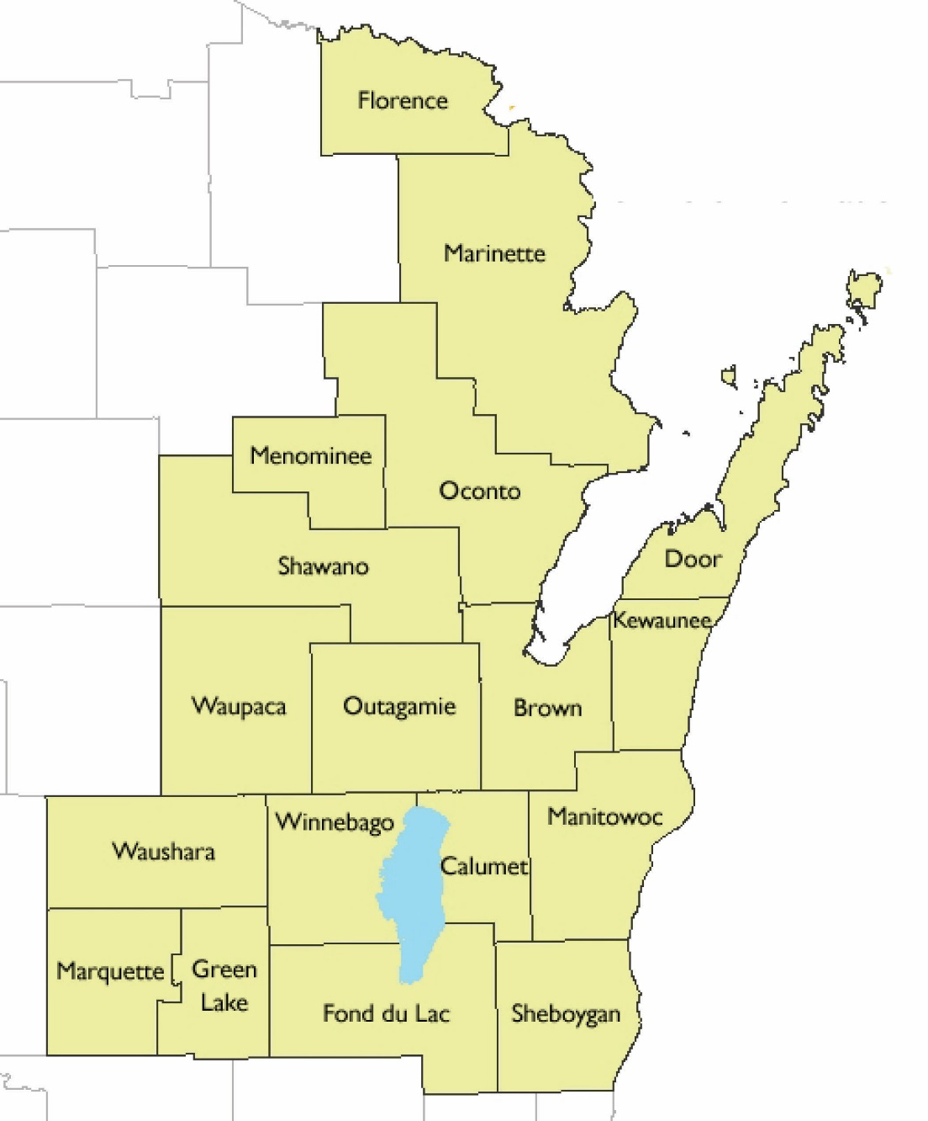
- Describe what it would be like to travel between these two cities in 1836. What modes of transportation could you take? How is this different than today? _________________
_________________
_________________
_________________
_________________
_________________
_________________
_________________
_________________
_________________
_________________
_________________
_________________
_________________
________________________________________________________
- What would communication have been like in 1836? How would you have communicated with someone who lived in Green Bay when you lived that far away? ________________________________________________________________________________________________________________________________________________________________________________________________________________________________

Growing Community (1850-1912)

• Vocabulary •
Franklin Hose Company

- Hose cart – the cart that carried the hose to put out fires; the small cart at the back of the Franklin Hose Company was pushed by firemen.

- Hand Pumper – a type of vehicle to help put out fires; the large hand pumper in the middle of the Hose Company is operated by pulling down on the hand bars on the side, which push water into a reservoir, which in turn forces water into the hose.

YMCA Library

- Boys’ club – in the case of Heritage Hill’s YMCA Library, a place for young boys to keep busy, be entertained, and to stay out of trouble.

- Taxidermy – the art of preparing, stuffing, and mounting the skins of animals in a lifelike form.

Print Shop

- Printing Press – a machine for printing text or pictures from plates or type.

- Calling cards – a card with a person’s name and address, indicating their presence (these are often compared to voicemail or answering machines; they were left at a person’s house or business to show that they were there).

Blacksmith Shop

- Forge – a furnace used to melt and shape metal.

- Anvil – a steel or iron block on which metal can be hammered and shaped.

- S-hook – a piece of metal bent into the shape of an ‘S’; may be used to hang pots and kettles over an open fire.

- Courting candle – a candle used in the 1800s to indicated the length of courting time (or length of a date); when the suitor would come to the home, the candle would be lit. When the candle burned down to the metal holder, the courting time was over.

Pre-Visit Activity

Create a Historic Site
(6th Grade & Up)

Not all of the buildings at Heritage Hill are original or historic buildings; some of them are reproductions. In this lesson, students will learn to understand historic preservation and the importance of historic sites.

Below is a list of concepts that your students should understand before taking part in this activity:
- Historical significance – a thing or event that was important to history and how it changed or impacted life, society, or culture.

- Artifacts – any item of cultural or historical interest.

- Historical preservation – the attempt to protect the quality of buildings, artifacts, landscapes, and other items of historical significance.

- Primary sources – a document or item that was created during the time that is being studied.

- Historical interpreter – a person who describes a historical event or time period and any items that have to do with that event or time period. Interpreters help people understand the meaning and significance of an event, time period, or artifact.
Tell your students…

This is Heritage Hill’s Mission Statement:

We are a living history park devoted to the preservation of our buildings and artifacts and the interpretation of the history of Northeastern Wisconsin and its people.

Ask your students…

- Why is Heritage Hill important? (What are the buildings’ historical significance?)

- What makes it a historic site?

- What can historic sites teach us?
(What life was like during that given time)

- Why would we want to save Fort Howard’s original buildings?
(So that future generations can continue to learn about Green Bay and Wisconsin’s history)

Activity:
Split the class into groups (groups of 3-5 will work best). Have each group choose a place in their hometown to declare as a historic site (tell them, “Imagine we are 100 years into the future. What places do you hope would still be around?”). This could be anything including a student’s birthplace, the gym where the basketball team won a trophy, or even the mall where they sat on Santa’s lap last December.

Students should…
- Be able to defend their choice of place on the basis of historic significance.

- Decide on an event or specific time that their historic site would be interpreted as.

- Brainstorm examples of artifacts that could be displayed at their historic site (have them list 3-4 artifacts that they would find useful).

- Determine what kinds of primary sources they could use to learn about the site.

- Determine where their historic site would be located (on the original site or moved elsewhere).

Students will present their historic sites to the class. They should explain the following:
- Why they chose that site.

- What its historic significance is.

- How they would be interpreting it.

- The significance of the artifacts that they chose to be at their site.

- What primary sources they would use to learn about the site.

- Where the site would be located.

- What visitors would learn from their site.

Closing the activity:
After the presentations, discuss why it is important that the historic site be kept in its original location. What are some reasons the site might not be able to be in its original location?
- It is easier to learn about what life was like in that area (for example, if the Fort Howard buildings were still in their original locations, you could see how close they were to the river, you could more easily imagine distances to various places, etc).
- One example of why a site might not be able to be in its original location is if the current owner wants the land but does not want the building, they might want to tear it down. Historical societies and museums have a tendency to want to preserve buildings so they fight to either keep the building up or have it moved somewhere where it can be preserved.

The students presented their historic sites in a classroom. How would learning about a site in a classroom be different from actually visiting the site? How would the experience be different?
- Sensory Experience – by actually visiting the sites, students can use their five senses to learn more. They can feel the furs in the Fur Trade Cabin, they can see a printing press at work, they can smell the cows on the farm, they can hear the blacksmith at work, and they can taste fresh butter made at the farm (during Fall Field Trips).
- Learning – some people learn and retain information better by seeing things first-hand or doing hands-on activities. By visiting a site, you’re learning by immersing yourself in history.

Would it be easier or more fun to learn on-site or in the classroom? Would a tour of a reproduction of a site be the same as going to the original site?

How would the students feel if someone destroyed their site? What would be lost?

Possible Modifications:
For a simpler/quicker lesson, as a class, choose one site and answer the questions together.

For a more in-depth project, have the students actually research the site. They could visit the site and take pictures of the site and anything they want as an artifact, access primary sources, and write about an event that they would interpret at their site. They could conduct oral histories by talking to their parents/guardians, friends, or any adults who are at that site.

Post-Visit Activity

Who am I?
(6th Grade & Up)

Divide your students into two or more groups or teams (maximum of 7 students per team; there are 7 characters). Find something to use as a bell or buzzer. The teacher will have the character cards on the following pages. From the clues on the cards, the students are to guess who you are talking about. Whoever rings the bell first gets a guess. Read the first clue. Let’s say Team A rings the bell first. If Team A guesses correctly after the first clue, they get 5 points. If they guess correctly after the second clue, that team gets 4 points, and so on. Each team only gets one guess per turn. If Team A gets the answer wrong after the first clue, the person on Team B can either guess right away or ask for another clue, but the person on Team A has lost their guess for that character. Continue until you’ve used up all of the character cards. The team with the most points after 7 character cards wins.

Henry Baird

Clue 1: In 1861, I was elected mayor of Green Bay, and I also became responsible for recruiting troops for the Civil War. (5 points)

Clue 2: I tried to prevent Madison from becoming the capitol of Wisconsin, but I was unsuccessful. (4 points)

Clue 3: After retiring from my profession in 1860, I tried to focus more on land sales. (3 points)

Clue 4: I served as Prosecuting Attorney when Chief Oshkosh was on trial for murder. (2 points)

Clue 5: I am a lawyer in my own law office. (1 point)

Caroline Tank

Clue 1: I was born in Holland and have a very rich family. (5 points)

Clue 2: I donated money to have a library built to be used as a place of cultural enrichment for young boys. (Hint: this is the YMCA library at Heritage Hill) (4 points)

Clue 3: I have many talents, which include painting, playing instruments, and speaking several languages. (3 points)

Clue 4: My house was a fur trader’s cabin before I lived there, and I renovated it into an elegant home. (2 points)

Clue 5: I have accomplished many things that were not common for women to accomplish during the time that I was live. (1 point)

Blacksmith

Clue 1: In order to be successful in my job, I have to be somewhat of a perfectionist. (5 points)

Clue 2: I don’t go to school to learn my job; I learn as an apprentice. (4 points)

Clue 3: My job can be very dangerous and I have to be careful not to burn myself. (3 points)

Clue 4: In the 1930s, I stopped repairing wagons and started making ornamental pieces. (2 points)

Clue 5: Find me if you need any metal work done! (1 point)

Printer

Clue 1: My job can be very messy. (5 points)

Clue 2: In order to keep up with competitors, my employer needs to keep up with the latest technology. (4 points)

Clue 3: My black sleeves help protect my clothing from being ruined. (3 points)

Clue 4: In one part of my job, I need to think upside down and backwards. (2 points)

Clue 5: Because of my job, you’re able to read the weekly newspaper. (1 point)

Moravian Missionary

Clue 1: My people are members of one large group who follows a leader. This large group is divided into smaller groups, and mine is the oldest; it was formed in the 1450s in Bohemia. (5 points)

Clue 2: Otto Tank was a member of my group. (4 points)

Clue 3: The building where my group worships was constructed in downtown Green Bay in 1851. (3 points)

Clue 4: A many-pointed star is the symbol of my religion and is meant to remind viewers of Christ as the Light of the World. (2 points)

Clue 5: I spread the word of the church and try to convert people to my religion. (1 point)

Otto Tank

Clue 1: I came to the United States after being asked to travel here as a Moravian Missionary. (5 points)

Clue 2: I helped remodel an old fur trader’s cabin to make it my home. (4 points)

Clue 3: I spent so much money that when I died I had a large amount of debt and my daughter wrote to her family saying that I “died of a broken heart and the failures of [my] lifetime.” (3 points)

Clue 4: The house that my wife and I renovated is now the oldest house in Green Bay. (2 points)

Clue 5: My wife decorated our home with a lot of her paintings. (1 point)

Fireman at the Hose Company

Clue 1: I am a volunteer. (5 points)

Clue 2: I volunteer partly to help my community, but also for the social scene – I like to play cards, checkers, and horseshoes with my fellow volunteers. (4 points)

Clue 3: Sometimes the tasks I carry out can be very physical – sometimes I have to push a heavy cart that is full of supplies, sometimes I have to carry buckets of water. (3 points)

Clue 4: My colors can be very misleading – my job has nothing to do with the Packers! (2 points)

Clue 5: I help keep you safe by putting out fires. (1 point)

Belgian Farm (1905)

• Vocabulary •
- Crop rotation – growing one crop on a plot of land one season, then the next season another crop in the same plot of land; preserves the ability of the soil to grow the crops well

- Parlor – a room in a home, hotel, or club used for conversation or gathering of guests; this is similar to today’s living room or family room

- Carding – to untangle the fibers of the wool by combing with a carding brush

- Shear – to cut the hair or wool from an animal

- Root cellar – an underground storage area for vegetables, especially root vegetables such as carrots and turnips

- Spinning wheel – a small machine driven by the hand or foot for making yarn or thread from wool

- Wood stove – a stove that is heated by burning wood inside of it

- Immigrant – a person who moves to a country to live there

Pre-Visit Activity

Immigrants’ Trunk
(2nd Grade & Up)

When many immigrants came to America, they were only allowed to bring what their whole family could fit into one large trunk. Because of this, they had to think about what was important to them; what would they take with them, and what would they leave behind? The immigrants had to keep in mind what they would be doing for work in America and what they would and would not need.

In this lesson, students should be given the drawings of the trunk and personal items. If there is time, have the students color the drawings. If you are limited on time, skip the coloring and simply have the students cut out the different personal items.

The object of this activity is to get the students thinking about what would be valuable to them to bring to America and show them how limited they had to be on their items. Once they have cut out the personal items, they are to choose which ones they want to bring with them. The catch is they are only allowed to bring what they can fit on top of their trunk or suitcase without overlapping the drawings.

Assign each student a “profession.” Make sure students take into account what their profession will be. Some examples of professions are: a teacher, factory worker, secretary, scientist, or lawyer. You can use any profession that you think of, as well.

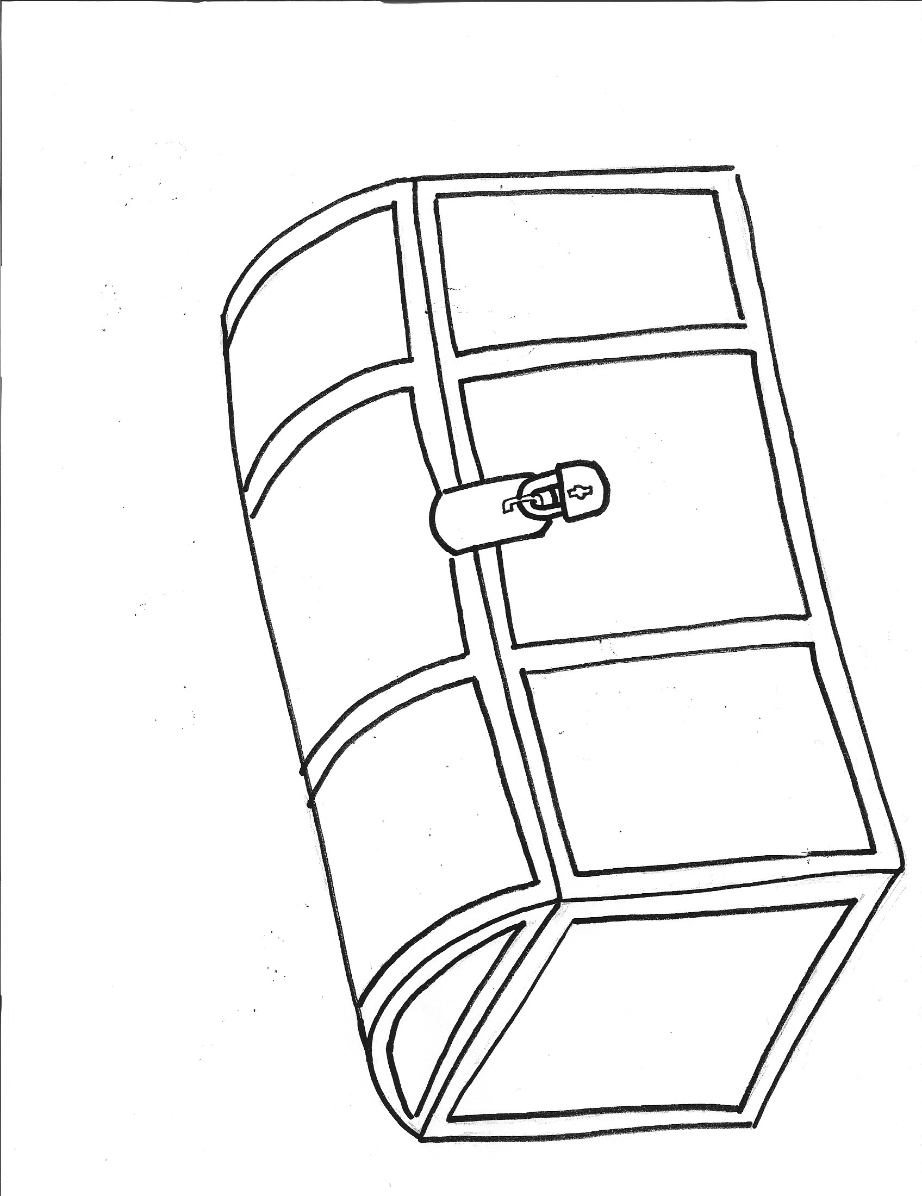
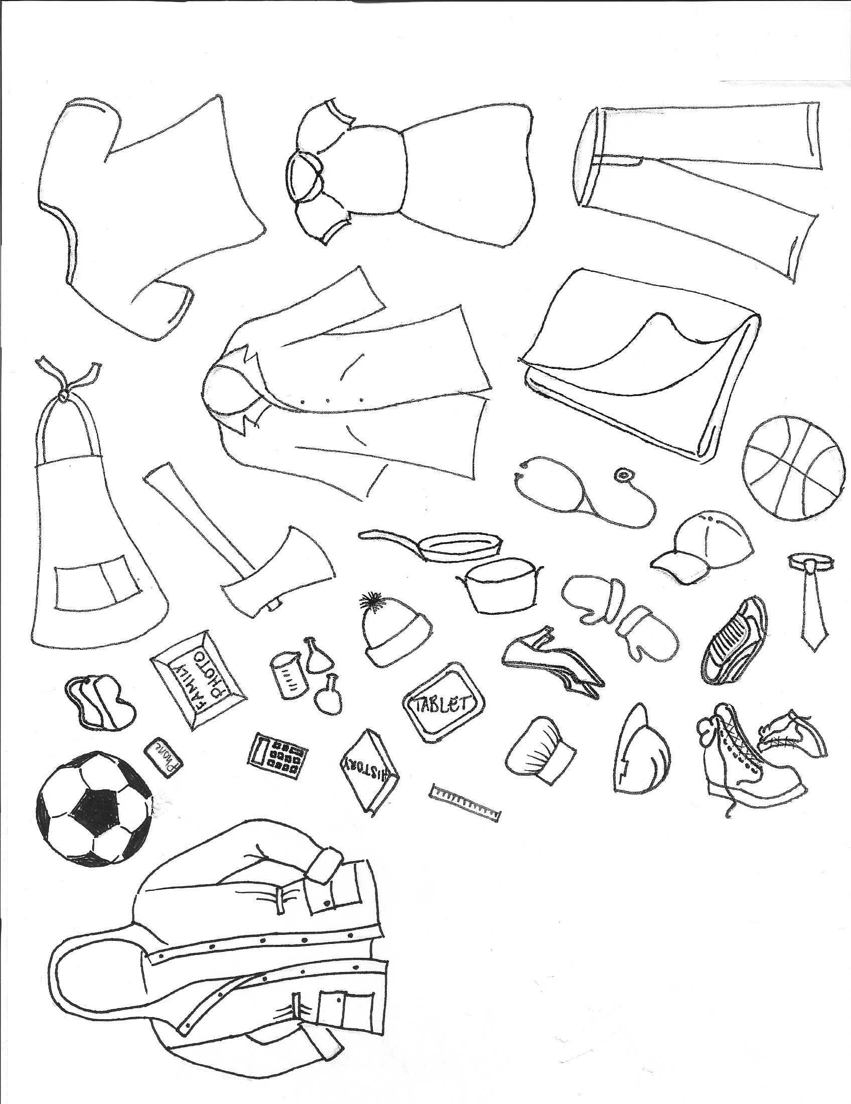

Post-Visit Activity

Thinking Like a Historian
(3rd Grade & Up)

Show the picture of the Massart family in front of the farmhouse to the students. Have students examine the picture and try to figure out as much as possible about the picture. Don’t give them any information about the photo when you begin, but feel free to prompt them with some of the following questions to get them thinking (we have first included the questions with answers, then on the following page made the questions into a worksheet). This can either be a discussion activity or have them answer the questions on the following worksheet. (This could also double as a good pre-visit activity).

- Can you guess about what time period this photo was taken in?
  - (circa 1904)

- Can you guess who all of the people are in the photo? (what their relationship is to each other)
  - (they are a family, includes grandmother, grandfather, mother, father, and children)

- Do we know for sure what their relationship is or who they are? Or is this just a guess?
  - (Unless a document accompanied the photo or there is writing on the back, there is no way to know for sure. Heritage Hill has documentation that this is the Massart family)

- Can the subjects’ clothing or buildings tell you anything about the lives of the people in the photo?
  - (Notice the colors of the bricks on the side of the house. The color of the brick is different colors in what looks like a random pattern. We do not know if this is because of the supply of the different materials or if it served a purpose. Have the students think about why the men are wearing hats – maybe they worked outside and needed protection from the sun. Also have them think about why the women are wearing aprons – maybe to protect their clothing from getting ruined. Why was this so important? Many people did not have a lot of money to spend on many pieces of clothing, so they protected the pieces that they already owned. Try to get them to guess what the log building on the left is (a barn) and why there is fencing on the right (a pen for an animal.)

- What do the people in the picture do for work?
  - (they are farmers)

- Why was this photo taken? What is the purpose of this photo?
  - (We do not know; again, unless it was accompanied by documentation, we can only speculate. Let the kids get creative with the possible reasons.)

- Why is it important to study historical photos?
  - (show information about everyday life, photographic evidence of something that happened, may show information about people who did not have a written language, you don’t need to be able to read to understand the history)

- How can photos limit what you can learn about something?
  - (The photo only shows one part of what is going on. The photographer can pick and choose which parts of a scene they want to document. This can easily change the mood of a photo.)

- What do you think was happening just before or after the photo was taken?
  - (Again, we do not know for sure. Let the children get creative with this question.)

- What questions do you have about the photo that you can’t answer without other sources?
  - (There is no right or wrong answer to this question. It is anything that the students are curious about that cannot be proven just by looking at a photo.)

Name: ________________________________________ Date: _______________________

Answer the following questions about the photo that your teacher has shown. Don’t worry – for many of these questions, there is no right answer! Use your historical analysis skills to try and answer the questions.

- Can you guess about what year this photo was taken in? ________________________________________________________________________
- Can you guess who all of the people are in the photo? (what their relationship is to each other) ________________________________________________________________________________________________________________________________________________________________________________________________________________________
- Do we know for sure what their relationship is or who they are? Or is this just a guess? ________________________________________________________________________________________________________________________________________________________________________________________________________________________
- What do the people in the picture do for work? ________________________________________________________________________________________________________________________________________________________________________________________________________________________
- Why was this photo taken? What is the purpose of this photo? ________________________________________________________________________________________________________________________________________________________________________________________________________________________________________________________________________________________________
- Why is it important to study historical photos? ________________________________________________________________________________________________________________________________________________________________________________________________________________________________________________________________________________________________
- How can photos limit what you can learn about something? ________________________________________________________________________________________________________________________________________________________________________________________________________________________________________________________________________________________________

- Can the subjects’ clothing or the buildings tell you anything about the lives of the people in the photo? ________________________________________________________________________________________________________________________________________________________________________________________________________________________________________________________________________________________________
- What do you think was happening just before or after the photo was taken? ________________________________________________________________________________________________________________________________________________________________________________________________________________________________________________________________________________________________
- What questions do you have about the photo that you cannot answer without other documents or photos? ________________________________________________________________________________________________________________________________________________________________________________________________________________________________________________________________________________________________

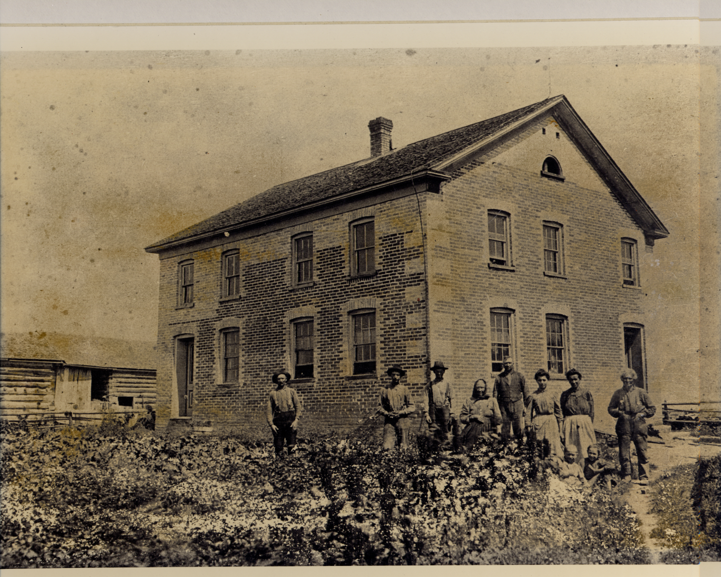

Write It! Define It! Draw It! Use It!

Assign four vocabulary words to each student or group. Have them write the word, define the word (in their own terms if they wish), draw a picture of it, and use it in a sentence.

Write It! | Define it! | Draw It! | Use it!
___ | ____________________________ |  | __________________________
___ | ____________________________ |  | __________________________
___ | ____________________________ |  | __________________________
___ | ____________________________ |  | __________________________

